Ques1: Write a program to implement the concept of multithreading by extending Thread class.

Source Code

**package** Lab10;

**class** Thread1 **extends** Thread {

@Override

**public** **void** run() {

System.***out***.println("This is Thread1 class");

}

}

**class** Thread2 **extends** Thread {

@Override

**public** **void** run() {

System.***out***.println("This is Thread2 class");

}

}

**public** **class** MultithreadingUsingThreadClass {

**public** **static** **void** main(String args[]) {

System.***out***.println("Hitendra Sisodia");

System.***out***.println("500091910");

Thread1 t1 = **new** Thread1();

Thread2 t2 = **new** Thread2();

t1.start();

t2.start();

}

}

Output

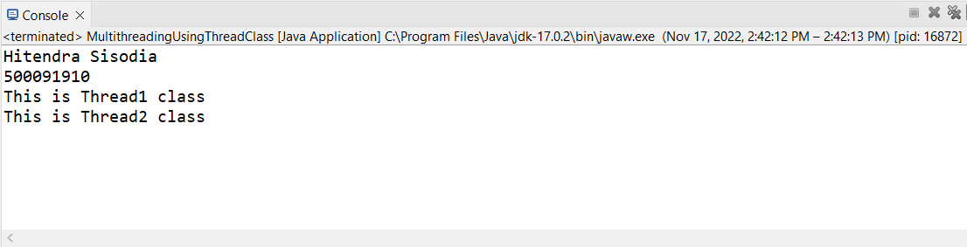

Ques2: Write a program to implement the concept of multithreading by implementing Runnable interface.

Source Code

**package** Lab10;

**class** T1 **implements** Runnable {

@Override

**public** **void** run() {

System.***out***.println("This is T1 Runnable Interface");

}

}

**class** T2 **implements** Runnable {

@Override

**public** **void** run() {

System.***out***.println("This is T2 Runnable Interface");

}

}

**public** **class** MultithreadingUsingRunnableInterface {

**public** **static** **void** main(String args[]) {

System.***out***.println("Hitendra Sisodia");

System.***out***.println("500091910");

T1 obj1 = **new** T1();

T2 obj2 = **new** T2();

Thread t1 = **new** Thread(obj1);

t1.start();

Thread t2 = **new** Thread(obj2);

t2.start();

}

}

Output

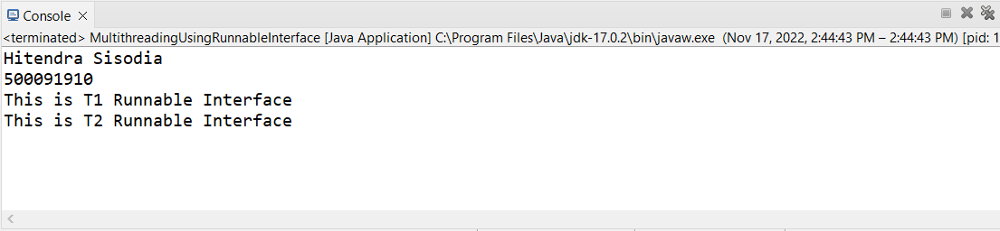

Ques3: Write a program for generating 2 threads, one for printing even numbers and the other for printing odd numbers.

Source Code

**package** Lab10;

**class** Thread3 **extends** Thread {

// Thread for printing even numbers

@Override

**public** **void** run() {

**for**(**int** i = 0 ; i < 10 ; i++) {

**if**(i % 2 == 0) {

System.***out***.println("Even Number: "+i);

}

}

}

}

**class** Thread4 **extends** Thread {

// Thread for printing even numbers

@Override

**public** **void** run() {

**for**(**int** i = 0 ; i < 10 ; i++) {

**if**(i % 2 != 0) {

System.***out***.println("Odd Number: "+i);

}

}

}

}

**public** **class** PrintEvenAndOdd {

**public** **static** **void** main(String args[]) {

System.***out***.println("Hitendra Sisodia");

System.***out***.println("500091910");

Thread3 obj1 = **new** Thread3();

Thread4 obj2 = **new** Thread4();

obj1.start();

obj2.start();

}

}

Output

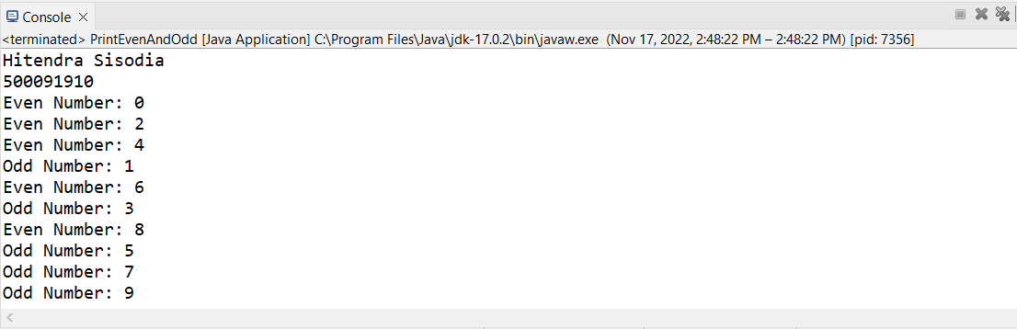

Ques4: Write a Java program that show multithreading between three threads. Set different priority to each thread and show output.

Source Code

**package** Lab10;

**class** C1 **extends** Thread {

**public** **void** run() {

System.***out***.println("This is Thread1 with highest priority");

}

}

**class** C2 **extends** Thread {

**public** **void** run() {

System.***out***.println("This is Thread2 with Normal priority");

}

}

**class** C3 **extends** Thread {

**public** **void** run() {

System.***out***.println("This is Thread3 with Lowest priority");

}

}

**public** **class** ThreeThreads {

**public** **static** **void** main(String args[]) {

System.***out***.println("Hitendra Sisodia");

System.***out***.println("500091910");

C1 t1 = **new** C1();

C2 t2 = **new** C2();

C3 t3 = **new** C3();

t1.setPriority(Thread.***MAX_PRIORITY***);

t2.setPriority(Thread.***NORM_PRIORITY***);

t3.setPriority(Thread.***MIN_PRIORITY***);

t1.start();

t2.start();

t3.start();

}

}

Output